Water Resources-Protection & Conservation

The City of Bloomingdale's community-specific Stormwater Management Plan as required by the NPDES, Phase I, MS4 Permit has been submitted and approved by the GA EPD. The City's plan included a commitment to increase public awareness about stormwater management and to inform our citizens as to how they can get involved in this program. The following articles includes information about groundwater and our access to it, several steps citizens can take to protect groundwater from pollutants, tips on conserving water resources, recycling information, etc. If you have any questions regarding this information, please contact the City Hall at: 912-748-0970.

What Is Groundwater?

Water is always moving. When rain falls to the ground, the water does not stop there.
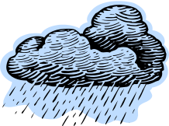
Some of our water flows along the Earth’s surface in streams or lakes, some of it is used by plants, some evaporates and returns to the atmosphere, and some sinks into the ground. Imagine pouring a glass of water onto a pile of sand. Where does the water go? The water moves into the spaces between the particles of sand.
Groundwater is water that is found underground in the cracks and spaces in the soil, sand, and rocks. The area where water fills these spaces is called the saturation zone. The top of the saturated zone is called the water table. The water table may be only a foot below the ground’s surface, such as with most of the Savannah area, or it may be hundreds of feet down.
Groundwater is stored in, and moves slowly through, layers of soil, sand, and rocks called aquifers such as the Floridan Aquifer where Chatham County pulls most of its drinking water. Aquifers typically consist of gravel, sand, sandstone, or fractured rock (like limestone). These materials are permeable because they have large connected spaces that allow water to flow through.
What Is So Important About Groundwater?
Groundwater is used for drinking water by more than 50% of the people in the United States, including areas such as Savannah and Chatham County. The largest use for groundwater is to irrigate the crops that will help to provide tonight’s dinner.
Where Can Groundwater Be Found?
Groundwater can be found almost everywhere. The water table may be deep or shallow, and may rise or fall. Heavy rains or melting snow may cause the water table to rise, or an extended period of dry weather, or drought, may cause the water table to fall.
If Groundwater Is Underground, How Do We Get It Out?
Water in aquifers is brought to the surface naturally through a spring or can be discharged into lakes and streams. Groundwater can also be extracted through a well drilled into the aquifer. A well is a pipe in the ground that is used to obtain water from an aquifer with the power of a pump. Some wells, called artesian wells, do not require the use of a pump due to natural pressures that force the water up and out of the well.
Can We Run Out Of Groundwater?
Groundwater supplies are naturally replenished, or recharged, by rain and snow melt. In some areas of the world people face water shortages because groundwater is used faster than it is naturally recharged.
Groundwater can become polluted, making it unsafe to drink. In areas where the material above the aquifer is permeable, pollutants can sink into the groundwater. Groundwater can become polluted by sources like landfills, septic tanks, leaky underground gas tanks, and by using too much fertilizer and pesticides. If groundwater becomes polluted it will no longer be safe to drink, which is why we all need to pay close attention to what is placed on the ground or near waterways.
It is important for all of us to learn to protect our groundwater in order to protect our future!
Fun Factoid: 51% of the people living in the United States depend on groundwater for their drinking water needs.
*****
Non-Point Source Pollution??
When it rains, the chemicals and pollutants around your home and yard are carried to nearby storm drains and then to surface waters such as the Savannah River. This type of “non-point” pollution can result in contaminated drinking water and destruction of wildlife. What can you do to help prevent non-point source pollution?
➢ Place pet wastes, litter, leaves and debris in proper trash bags.
➢ Dispose of used oil, antifreeze and grease with sand or a substance that will soak up the fluids rather than hosing them into the street where they can reach nearby waterways.
➢ Allow buffer strips and/or thick vegetation to grow along water bodies to decrease runoff and filter pollutants.
➢ Plant more vegetation in your yard such as trees, shrubs, and ground cover. They will absorb 14 times more precipitation than a grass lawn and do not require fertilizer.
➢ Use natural fertilizers rather than chemicals and pesticides for the lawn, or at least reduce the application by mixing.
➢ Wash your car on the grass so soapy water is absorbed in the ground and does not enter storm drains.
*************************

What Does Your Car Have to Do With Water Pollution???
Dirty or leaking equipment and vehicles can deposit oil, grit, coolants, and other pollutants onto the ground. From there, these pollutants can filter through soils to the ground water table or be washed by stormwater into a lake, river, or stream.
In addition, spills are common during fueling and other maintenance activities. Designing outdoor maintenance areas to completely contain leaks and spills is an important part of protecting water quality.

Eight Steps to Preventing Water Pollution
Regularly maintain equipment and vehicles.
Perform maintenance activities only in designated areas.
Properly design outdoor storage, fueling, and other maintenance areas to prevent stormwater from washing pollutants into nearby drains or waterways.
Keep service areas clean and take steps to prevent spills.
Prevent overfilling gas tanks to prevent any spills that may occur from reaching the soil or groundwater.
Properly store, use, and dispose of maintenance products.
Completely drain and recycle used oil filters.
Wash your car in a grassy area to not only water your grass but prevent any oils, soaps or materials rinsed off your car from entering the nearby storm drains.
*************
Healthy Households
People need clean, healthy habitats just like wildlife. Your yard isn't the only place where you can take action to decrease the pollution to our air, water and other resources. Look at your own household, for instance. The ways that you consume water and energy, the cleaning products you use and even the items you purchase, use and throw away can have a very significant health impact for you and wildlife.
In the sections below, you'll learn how easy it is to live a "greener," healthier lifestyle in and around your home. When you create a "green home" you do more than make the place where you live more livable. You do a service to your community, setting an example for your neighbors to follow.
You might want to experiment with one or two suggested actions to start with, and then add more until you are doing something in each section that is covered here.
Automobiles and Travel
Is it possible to be an environmentally responsible citizen and still enjoy the luxury of automobiles? The answer depends largely on how we drive and care for our cars. There's no question that motor vehicle exhaust is a major source of environmental and health problems, from air pollution and global warming to water pollution and acid rain. Cars also create trash; tens of millions of used tires, batteries, oil filters and other goods are thrown away each year.
There are many steps you can take to lessen the environmental impacts of cars, starting with buying the most fuel-efficient car you can find.
What You Can Do
1. Care for Your Car
Keep your car tuned, tires inflated, filters cleaned and oil changed regularly. Check the air conditioner for leaks. Buy the lowest octane gas recommended in your owner's manual. Also, make sure your gas station recycles oil, tires and batteries and disposes of antifreeze properly.
2. Drive Right
Observe speed limits, accelerate smoothly and moderately, avoid tailgating or excessive idling. Try not to drive during peak periods.
3. Don't Drive
Walk, bike, skate, jog or take public transportation. Telecommute one or two days a week. Set up a carpool or vanpool service where you work.
Green Shopping
The world's growing population is creating a mushrooming demand for more goods — including many cheaply-made, disposable products. Every new human life brought onto the Earth creates a need for food, clothing and shelter. Producing all those goods and services requires more and more energy. This use creates more waste and pollution.
The products and services we buy need not be destructive to the environment. By choosing carefully, we can have a positive impact on the environment without significantly compromising our way of life. That's "shopping green".
What You Can Do
4. Buy Less
Purchase goods in bulk or in the largest size possible. Rent or borrow rather than buy, or buy cooperatively. When appropriate, buy reused, reconditioned or refurbished rather than new. Think about whether you really need more clutter.
5. Shop Smart
Avoid single-serving and disposable packaging. Avoid things you cannot (or will not) recycle. Buy reusable or refillable products, and those from companies with good environmental records. Seek out goods grown or manufactured locally.
Home Improvements
Keeping your home in tip-top shape is one of the greenest things you can do. By keeping things tuned, painted, repaired and refurbished, you lengthen their useful lives and make them more efficient. But not every home-improvement product is good for the environment. Some paints, cleaners, glues and solvents can pollute the inside and outside air and harm you and your family's health. Check these products out before purchasing.
It's not just what we buy, it's how we use and dispose of it. Keeping hazardous waste out of the trash — where it can leak into the water supply or pollute the air — will ensure that your fix-up project is friendly to your home and everyone else's.
What You Can Do
6. Clean Green
Buy nontoxic cleaners and other products and use them properly. Follow directions when storing or disposing of leftovers.
7. Fix it Up
Use low-impact products and materials. Install energy-efficient lights and appliances. Use woods from sustainably grown forests (look for independent certification labels).
Reducing Wastes
Americans generate more trash per capita than people in any other country. On average, each American discards about 4.4 pounds of solid waste every day, only about a pound of which is recycled, composted, or otherwise recovered. The remainder goes to landfills or incinerators.
Where to dump trash is only one problem. More serious are the hazardous substances in our trash, including many common household items like batteries, motor oil, cleaning products, paints and others. These chemicals can pollute the air, soil and water, harming the earth and our health.
What You Can Do
8. Reduce Trash
Avoid wasteful packaging and single-use products that can't easily be recycled. Buy reusable, repairable, rechargeable or refillable products, and those made from or packaged in recycled material.
9. Eliminate Toxics
Seek alternatives to caustic household cleaners, pesticides, paint removers and other products containing toxic chemicals. Carefully dispose of leftovers at a waste disposal facility in your community.
10. Reuse and Recycle
Try to reuse material before you recycle. Start a compost pile. Mulch or compost yard waste. Sell or donate used clothing, furnishings, books, appliances, etc. Borrow or rent rather than buy seldom used appliances.
Energy Conservation
We waste a lot of energy - and money. Most experts agree that we can easily cut pollution and home energy costs by using energy resources wisely.
What You Can Do
11. Don't Waste Energy
Lower your thermostat in winter and raise it in summer. Have your furnace and air conditioner serviced and cleaned. Turn down your water heater to 120° - 140°F. Check your refrigerator for leaky gaskets around the doors. Caulk, weather strip and insulate walls, attics, basement, windows, doors and pipes.
12. Buy Energy Savers
Install compact fluorescent light bulbs wherever practical. Add dimmers/timers to light switches where appropriate. Install a programmable thermostat. Purchase energy-saving appliances.
Water Conservation
By wasting less water, we leave more water for other uses, like recreation and fishing, and reduce the risk of pollution. Conserving water reduces health risks too. Wise water use can help improve the health of both people and the environment.
What You Can Do
13. Don't Waste Water
Install low-flow shower heads and faucet aerators. Fix leaky faucets and toilets. Water the lawn and garden with timers and drip hoses early or late in the day.
14. Keep Water Clean
Properly dispose of paints, motor oil and pesticides by recycling or sending to a hazardous waste collection site. Use low-impact gardening techniques that avoid pesticides and chemical fertilizers. Buy organic produce, grown with fewer pesticides.
---------------------------------

Protecting Your Water and Septic System

If your home has a septic system, it requires regular maintenance to prevent costly damage and repairs. Septic systems are designed to safely use natural processes such as “helpful bacteria” to treat and dispose of the wastewater generated in your home. If a septic system is not maintained, untreated human waste may contaminate drinking water supplies and negatively impact the environment. Keeping your septic system working properly is a wise investment for economic, human health, and environmental reasons.

What is the Importance of Maintaining Your System?
Pumping the septic system regularly every 3 to 5 years will prevent the system from overflowing thereby protecting not only your investment, but also protecting the drinking water as well as any nearby streams. If a septic tank were to overflow, the wastewater would mix with solid waste in the tank and might possibly clog the associated drainfield causing sinks and toilets to “back up”. Also, the raw waste may flow into drinking water wells or runoff into streams that lead to the ocean and estuaries and this raw waste in coastal waters may contaminate shellfish and ultimately result in waters that are not fit to swim in.
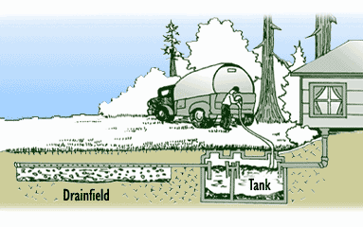
Here’s What You Can Do:
- Have your septic system pumped out every 3 to 5 years.
- Do not pour household chemicals down the drains. Many household chemicals can harm the helpful bacteria in your septic system and without these helpful bacteria the system may malfunction.
- Do not flush materials that will not decompose in the septic tank and end up clogging the system. These include items such as: diapers, kitty littler, baby wipes, tampons, and cigarette butts.
- Try to limit your use of the garbage disposal. It can add excess materials to the septic system that take a long time to decompose…try composting your food instead.
- Do not pour the following things that may kill the helpful bacteria in your septic system down the drain: paints, acids, solvents, drain cleaners, oils, pesticides and large quantities of bleach.
- Reducing the amount of wastewater generated can extend the life of your septic system. Less potable water in the septic tank provides more storage area for the raw waste. To decrease the water amounts going into the septic tank, think-water conservation! Some water conservation methods include: installing low flow toilets and showerheads; taking shorter showers; turning off the water when you brush your teeth, shave or wash the dishes; and repairing leaking faucets and toilets.
- Look for signs of trouble with your system. Some warning signs that a septic system is not working properly include: foul odors in your home or yard; wet, spongy ground or lush plant growth that appears near a leaky septic tank or drainfield; and plumbing fixtures that drain slowly because of a clog in the house pipes, septic system, or drainfield.
- Respond quickly to any problems you observe and call a professional to address the problem.
For more information on these Community Partners For Clean Water series tips, please call the Metropolitan Planning Commission Water Resources Section at (912) 651-1454.
*****************************
Conserving Water at Home
By Jackie Jackson - MPC
Most of us take for granted an abundant supply of good, fresh water. We meet our daily needs when we turn on the faucet and get seemingly unlimited running water. However, this situation is changing as more and more communities face water shortages.
Water shortages are certainly inconvenient and even scary. At first, they are hard to understand when we know that the United States daily rainfall equals 4.2 trillion gallons. However, water is not always located where it is needed and demand keeps increasing.
In the last 30 years the United States demand for water has grown faster than our ability to find new water sources. During this period total water use tripled, while our population grew 52 percent. Demand for water continues to rise sharply but population has increased only slightly in the last few years.
Water Use
Just how much water do we consume each day? Studies show wide variations in different areas of the country and between urban and rural households. According to the American Water Works Association, the average United States resident uses about 110 gallons a day. Statistics for our part of the country show that a typical consumer uses 50 to 75 gallons daily inside the home. We use most for toilets followed by bathing, laundry/dishes and cooking/drinking.
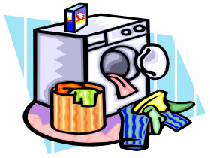
Water use varies with time of day and season of the year. Overall, households use less water during the winter and in the early morning while most people are sleeping. Peak consumption is typically in the spring and summer and when the family gets home later in the afternoon. However, everybody’s use is a little different and home water use mirrors each person’s lifestyle and behavior.
Conservation – It’s Everyone’s Responsibility
Water shortages are real, touching many United States communities each year. Because water conservation is a good defense against shortages, it should happen all the time, not just when shortages occur.
To begin conserving water, everyone needs to know some simple facts:
1. Water is a limited resource.
2. Water costs a great deal in energy and money to pump, move and purify.
3. Water consumption can be reduced significantly in the average home through simple practices.
It isn’t hard to conserve water, it doesn’t change our lives drastically. It’s mostly a matter of using good common sense. Think about water – and when you do – think about conserving it!

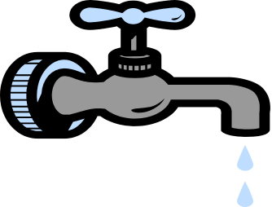
***********************
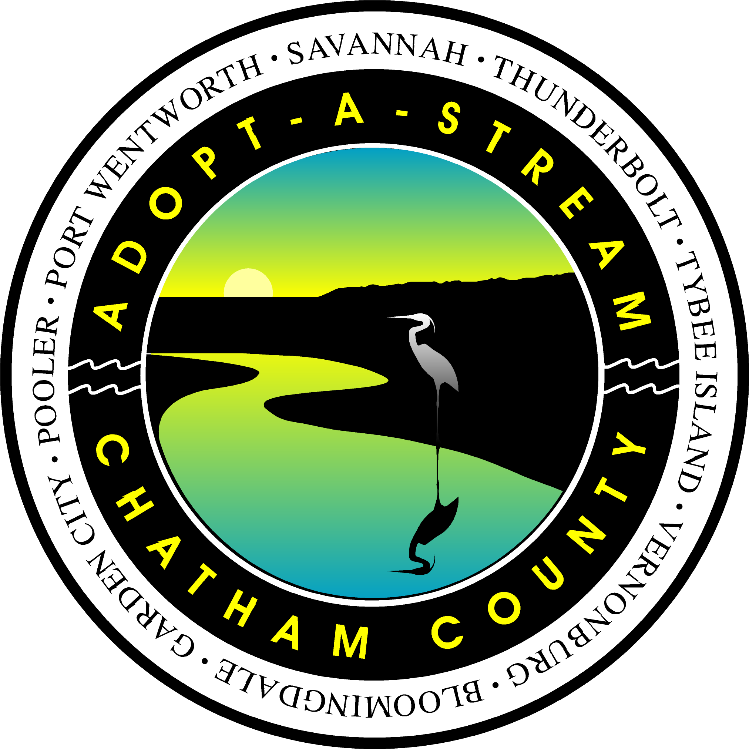
Chatham County
Adopt-A-Stream
Adopt-A-Stream is a statewide program of the Georgia Department of Natural Resources, Environmental Protection Division (GA EPD), designed to promote and increase water quality awareness, public education and community involvement in protecting one of the most valuable resources – water.
Volunteers adopt a segment of a stream, canal, or other body of water for one year. During this year, Adopt – A- Stream groups select various monitoring activities that best suit their own goals and interests. Adopt- A- Stream involves volunteers of all ages and backgrounds, including individuals, school groups, scout troops and civic organizations. The Southeast Regional Training Center at Savannah State University serves Chatham County and conducts training workshops for all levels of activity and issue quality assurance certification to all of the volunteers. Adopt-A-Stream daily operations Chatham County are handled through the Chatham County – Savannah Metropolitan Planning Commission (MPC).
We are still looking for groups or individuals that wish to become involved in the Adopt-A-Stream monitoring program!!!

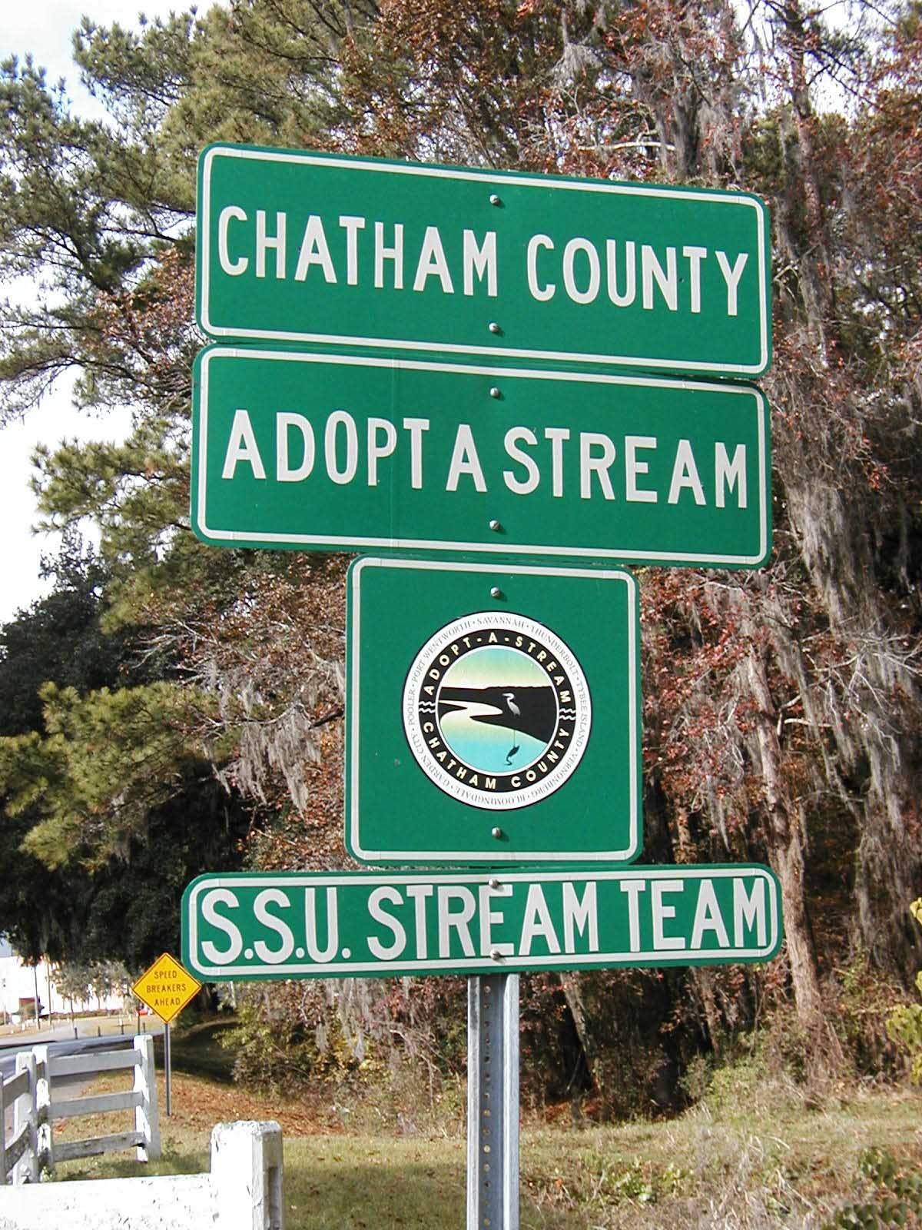
For information on the training workshops please contact:
Dr. Joe Richardson Marine Sciences Program, SSU
P.O. Box 20583
Savannah, Georgia 31404
(912) 356-2809
E-mail: richards@savstate.edu
For more information about the Chatham County Adopt –A-Stream program please contact:
Ms. Jackie Jackson
Chatham County – Savannah
Metropolitan Planning Commission
Water Resources Planner
P.O. Box 8246
110 East State Street
Savannah, Georgia 31412-8246
(912) 651-1454
E-Mail: jjackson@TheMPC.org
---------------------------------------------------------

Xeriscape - Water Wise Landscaping
Xeriscape is a simple, seven-step approach to developing a lush but water-wise landscape. The beauty of this method is that it not only saves water, but it saves time, energy and money.
The following information was adopted from the University of Georgia Cooperative Extension Service publication entitled, “Xeriscape – a guide to developing a water-wise landscape.”
1.) Planning and Design: Landscapes should be designed with different water use zones.
High Water Use Zone - Plan your high water use zone for small but highly visible areas, like near your front door. These areas may require regular irrigation.
Moderate Water Use Zone - These areas will require occasional irrigation and cover a larger part of the landscape
Low Water Use Zones - These areas are watered only by natural rainfall although some plants may require irrigation until properly established. In order to conserve water, the low water use zones should encompass the largest part of your landscape. Low water use zones are perfect for private but functional areas like the backyard.
2.) Soil Analysis: Soils differ in their ability to hold water and nourish plants. It’s important to test your soil so that you have a healthy foundation for your landscape. Follow these three steps to a healthy lawn and garden.
• Have the pH and fertility of your soil tested by UGA Extension before you fertilize- your soils may not require any fertilizer at all.
• Test soil compaction. Compacted soils are unhealthy for plants and can generate as much runoff as pavement. To test for soil compaction, try sinking a screwdriver into the ground without pounding. If the screwdriver doesn’t penetrate easily, aerate the soil with a hand or mechanical corer. Don’t use spike type rollers: these actually make compaction worse.
• Examine soil texture and drainage. Neither very sandy nor heavy clay soils provide a good foundation for lawns or other plantings. To examine soil texture, squeeze a hand full of soil into a ball. If the soil falls apart it’s too sandy; if the soil stays in a clump it has too much clay. In general, soil with a good texture will stay pretty spongy.
3.) Appropriate Plant Selection: Plants that are suited to the coastal Georgia environment will require less water, chemicals and maintenance to survive in your landscape. Choose plants with watering needs that match the zone they're planted in. For a list of appropriate plants, call the MPC Water Resources Program at 651-1454.
4.) Practical Turf Areas: Consider the functional and/or aesthetic value of turfgrass when planning your landscape. Keep irrigated turf areas small and use drought resistant varieties such as Tifway Bermuda, Common Bermuda, and Centipede. Don't use turf grass as filler for large landscapes. Reduce the need for fertilizers, pesticides, mowing, and watering by replacing turf grass with lower maintenance plantings.
5.) Efficient Irrigation: A water smart landscape should only require minimal irrigation after it is established. In order to be as effective as possible, irrigation must be planned in accordance with the water needs of the different parts of your landscape. Applying the same amount of water to the entire landscape defeats the purpose of Steps 1 and 3. Proper watering will depend on a number of factors including soils and current weather patterns. In general:
• Adjust the timers on automatic sprinkler systems every week or so, depending on the weather. (If soils are healthy, turf grass should only need about 1" of water a week during warm weather.)
• Avoid overspray onto impermeable surfaces such as roads, driveways, and sidewalks.
• Maintain irrigation systems. This may involve repairing leaks, broken heads, and risers, as well as adjusting application patterns and rates to minimize runoff.
• Irrigate with reuse water whenever and wherever possible. Using anything from shallow wells to air conditioner condensate can help conserve our valuable drinking water.
• Install rain sensors on all automatic irrigation systems. Watering when it’s raining is wasteful and can result in stormwater runoff.
6.) Use of Mulches: Mulches hold moisture in the soil, prevent crusting of the soil surface, insulate roots from extreme temperatures, discourage soil borne diseases, and prevent weeds that compete with landscape plants for water. Pine straw, chipped or shredded bark, and fall leaves are all commonly used and readily available types of mulch. Plastic film is not recommended as it prevents oxygen, nutrients and water from reaching plant roots. Chatham County has a yard waste recycling program that produces free mulch for citizens of Chatham County. For more information on where you can get free mulch call (912) 652- 6863.
7.) Appropriate Maintenance: Xeriscape-type maintenance includes the following:
Appropriate Mowing, Deep Roots - Mowing your grass at the appropriate height will keep lawns thick and healthy. St. Augustine turf should be kept at about 3", Centipede turf should be mowed to 1 1/2 - 1 3/4", and Zoysia turf should be mowed to about 2". Try to mow often enough so that only the top one-third of the grass blade is cut. If you are unsure about what height to cut your turf, check with your local extension agent.
Recycle Clippings - If left on the lawn, clippings provide important moisture and nutrients (clippings can provide up to half the nitrogen needed by your lawn). Since they’re about 85% water, small clippings quickly break down and don’t cause thatch. Make sure that clippings are no more than 1" long or they may be too large to break down before your next mowing.
Managing Thatch - Thatch is the woody remains of grass (roots, stems, and sheaths). Thatch builds up when there aren’t enough microorganisms in the soil to break woody grass remains down. Don’t use insecticides and keep soil aerated to encourage microorganisms and reduce thatch. If thatch builds up over 1/2", aerate the soil and sprinkle compost or sifted topsoil over the lawn (a practice called top dressing) instead of fertilizing.
Pruning, Fertilizing, and Pest Control - Limit fertilizing and pruning plants during times of drought to avoid water-demanding new growth. Target pests only after they begin to affect the appearance and health of your plants. Limit your control measures to the affected areas and avoid spraying the entire landscape. Never apply chemicals before a forecasted rain event.
Let Plants Tell You When They Need Water- Watch for signs that your plants are experiencing water-related stress. Signs can include leaves that turn a gray green or fall color and wilt. Turf grass will turn a dull grey-green color and the blades will wilt and roll inwards.


